Bollington Art Group
Mondays: 8, 15, 22, 29 Oct and 5 Nov 2025
Workshops with Julia Borodina www.juliaborodina.co.uk

Explore the exciting watercolour working methods by J. M. W. Turner

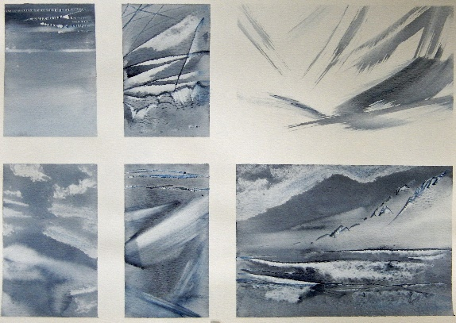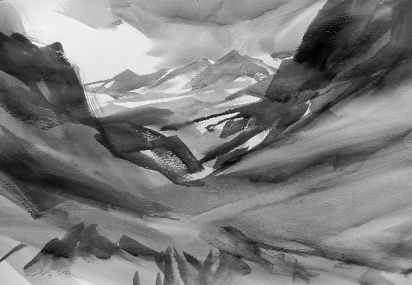
Session 1: Turner’s tips on tone and painting depth. You will do a number of monochromatic exercises practising washes, lifting, scratching and blending, before painting 1-2 studies of Coastal Mountains/ Mountain Path.
Special equipment for the session: Indigo (alternatively you can use Payne's Gray or blue and black), sponge, palette knife, kitchen towel/ tissues, A4 or A3 paper.

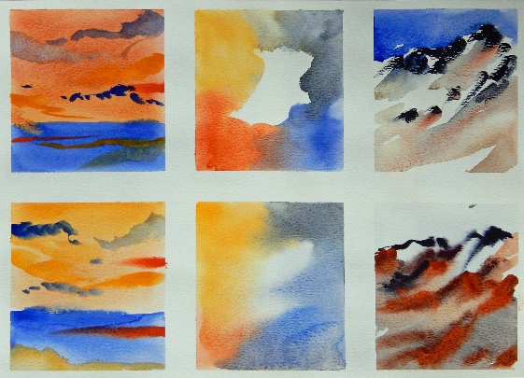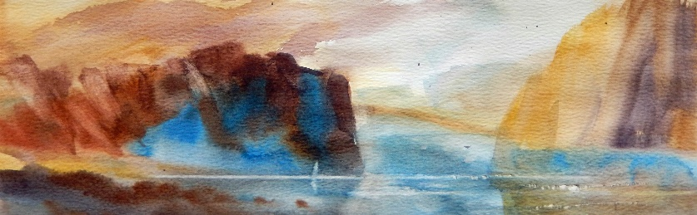
Session 2: Turner’s use of warm and cool colours. You will do a number of colour experiments, exploring colour mixing, colour contrasts, create soft and sharp edges, test painting with use of line and dry pigment. You will then create 1-2 studies of a Scottish Loch.
Special equipment for the session: A4 or A3 paper.

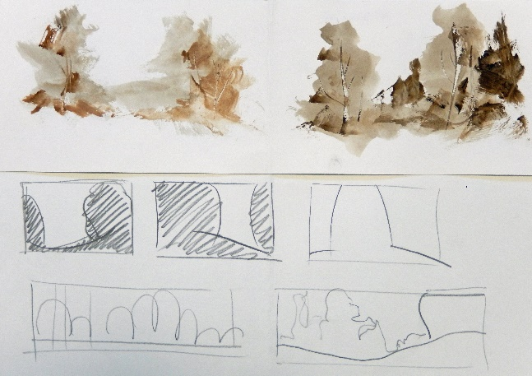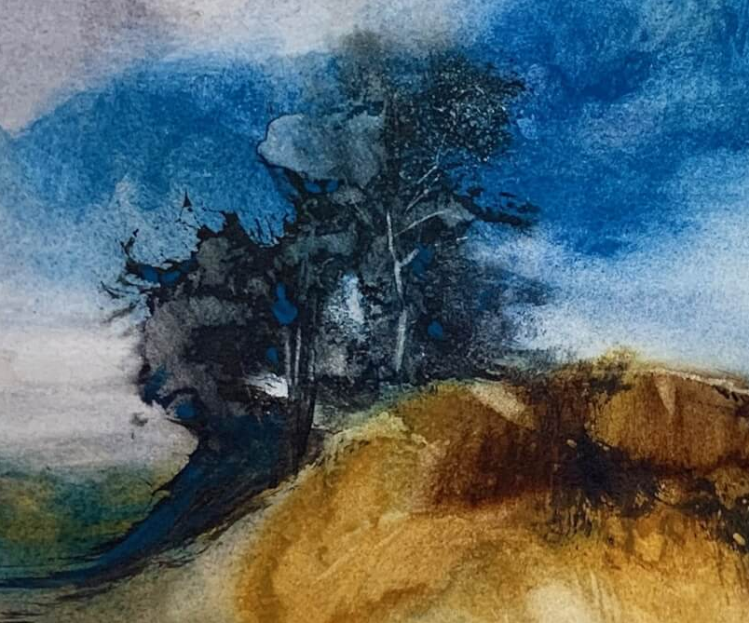
Session 3: Practicing dynamic brush marks. You will experiment with various brushes to achieve accidental creative strokes. You will then create various small studies on trees including a final composition.
Special equipment for the session: various brush sizes, flat brushes, Chinese brush, wooden wedges, palette knife, A3 Drawing (normal) paper – for experiments and samples, A3 Watercolour paper.

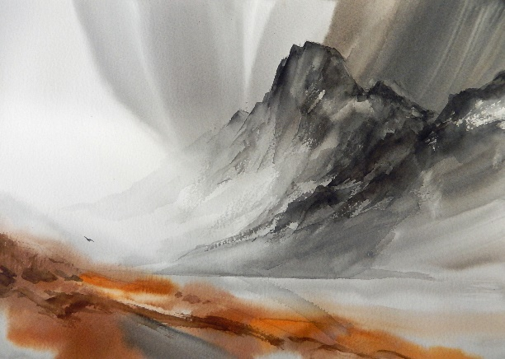
Session 4: Painting an atmosphere. You will experiment with a sponge and practice to lift, smudge, blend and apply whispery strokes. You will then create a study from a Mountain Valley above or from your own photograph.
Special equipment for the session: sponge, palette knife, A3 Drawing (normal) paper – for experiments and samples, A3 Watercolour paper.

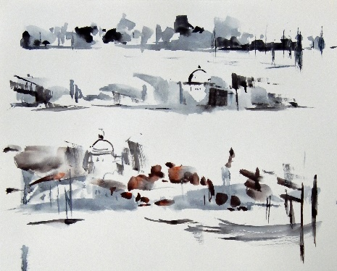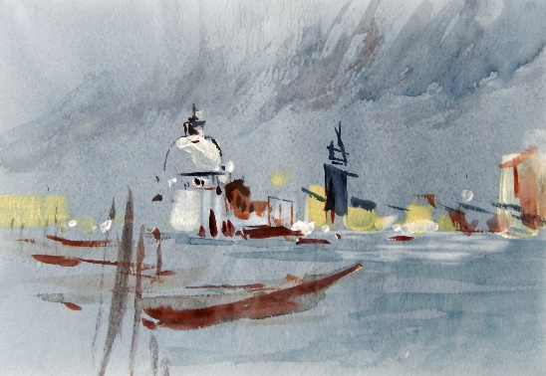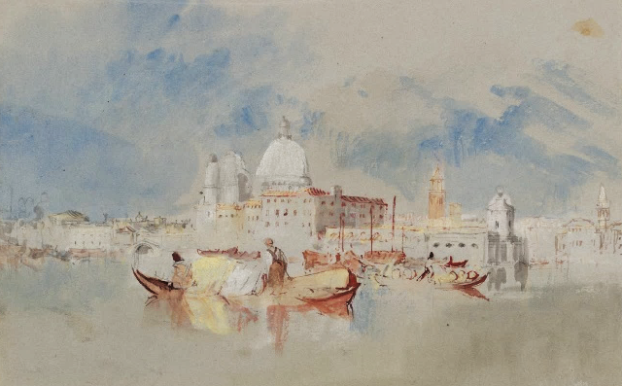
Session 5: Painting Venice in the style of Turner. You will paint on dark wash. You will then play with various brushes and tools (timed exercises) to paint buildings in a free, spontaneous way. Finally, you will produce a study of a city by water.
Special equipment for the session: Indigo, White Acrylic paint, sponge, A3 Drawing (normal) paper – for experiments and samples, A3 Watercolour paper.
Equipment we will be using over 5 weeks:
- A4, A3 or A2 size Watercolour Paper
- Drawing (normal) paper – for experiments and samples
- board
- Watercolour paints, just bring what you have (Julia will be using White Nights blocks)
- Masking tape
- Palette or large white plate
- Various Watercolour brushes: mop brush, flat brushes, old rough brush, wash brush, household painting brush, if possible.
- Chinese Brush
- Sponge to paint with (Julia will bring spare sponges)
- Palette knife (Julia will bring spare)
- Wooden canvas wedges to draw with (Julia will bring for everyone)
- White Acrylic paint (Julia will bring for everyone)
- Watercolour crayons (or pencils) if you have any (Julia will bring some to try)
- Kitchen roll
- Water pot or two
- Craft knife or scissors – for scratching the surface
- Spray bottle (optional)
- Hair dryer (optional)
- Pencil and eraser

